

**Adama Science and Technology University**

**School of Electrical Engineering and Computing**

**Course Title:**Electronic Circuit I

**Course Number:**ECE2101

**Lab:** Experiment Number 1

**Title:**Diode Characteristics

**Prepared by:**

**Name ID No.**

**Submitted to:**

Date of conduction: November 10, 2016

Date of submission: November 17, 2016

**Acknowledgement**

We would like to acknowledge our lab assistantfor his support and explanation in the laboratory. Through the group work and experiment we were able to comprehend the topics that were raised and able to communicate with each other well.

**Theoretical Background**

A semiconductor diode is simply a PN junction that has two terminals: An **anode** and a **cathode**.The diode is a two terminal semiconductor device that allows current to flow in only one direction. It is constructed of a P and an N junction connected together.

In general, semiconductor materials fall into one of two classes: *single-crystal* and*compound.* Single-crystal semiconductors such as germanium (Ge) and silicon (Si) have arepetitive crystal structure, whereas compound semiconductors such as gallium arsenide(GaAs), cadmium sulfide (CdS), gallium nitride (GaN), and gallium arsenide phosphide(GaAsP) are constructed of two or more semiconductor materials of different atomicstructures.

Both *n* -type and *p* -type materials are formed by adding a predetermined number of impurityatoms. An *n* -type material is created by introducing impurity elements thathave *five* valenceelectrons ( *pentavalent*), such as *antimony* , *arsenic* , and *phosphorus.*

The *p* -type material is formed by doping a pure germanium or silicon crystal with impurityatoms having *three* valence electrons. The elements most frequently used for this purposeare *boron* ,*gallium* , and *indium* . Each is a member of a subset group of elements in the PeriodicTable of Elements referred to as Group III because each has three valence electrons.

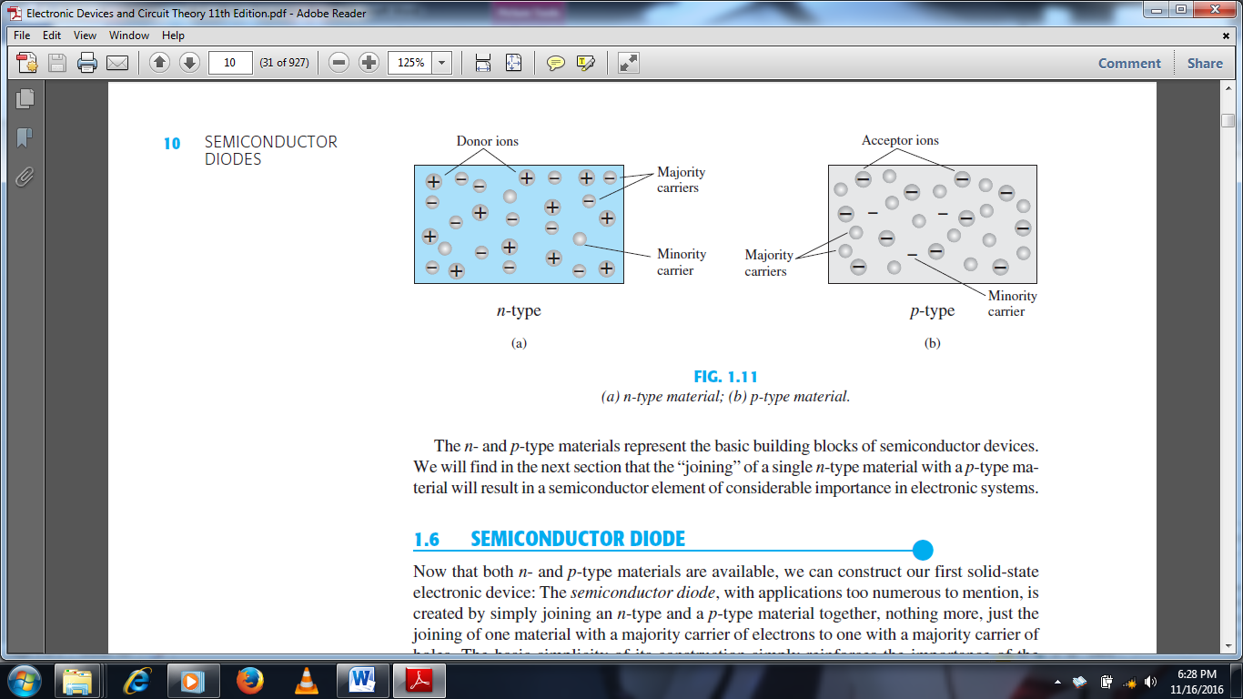

**Lab – 1: Diode Characteristics**

**Objectives:**

* To test and identify anode and cathode terminals of the diode.
* To study diode characteristics.

**Apparatus Used:**

* DC power supply
* Multimeters (Digital and Analogue)



* Connecting wires
* Diodes: Silicon (1N4007)

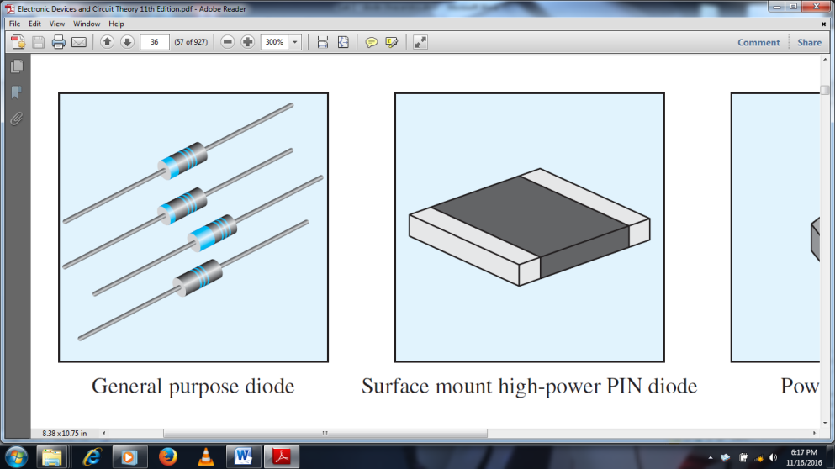

* Resistors: 100 $Ω$, 330 $Ω$
* Breadboard

**Procedures**

1. **Diode Testing**
2. First we placed the diode on a good flat surface.
3. Then we brought a Multimeter and adjusted the measuring region to Resistor region and also adjusted the range of measuring.
4. Then we identified the anode and cathode terminals of the diode. The end of the diode that has a small strip color is the cathode terminal.

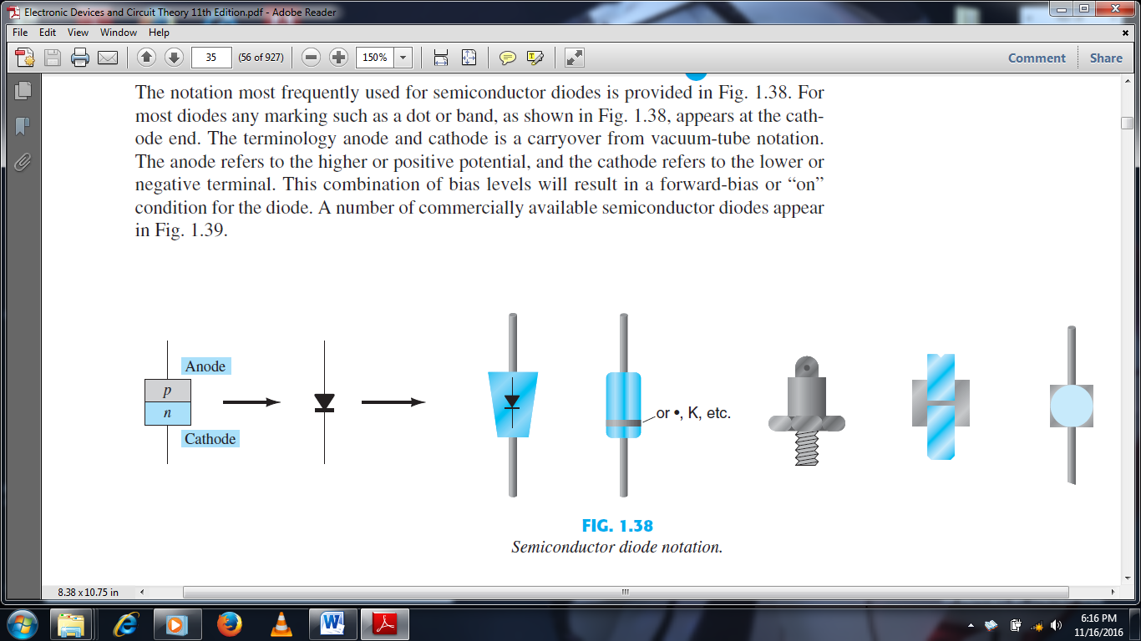

1. Then we placed the positive probe of the meter to the anode end and the negative probe of the meter to the cathode end of the diode. This resulted in a forward biasing and we obtained a small reading. This means the diode is a short circuit and there is a flow of current through the diode.

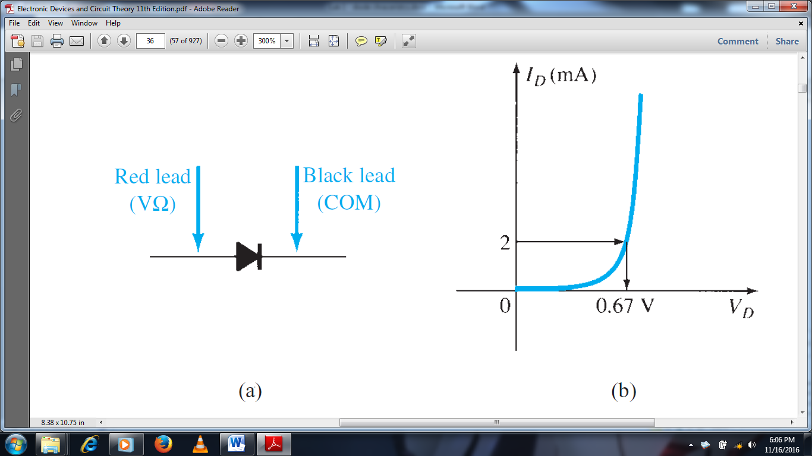

1. After this we switched the probes and attached them to the opposite ends. This resulted in reverse biasing and our reading showed 1 meaning that the resistance was a large number (infinity or $∞$). In this case our diode would not conduct and it is an open circuit.

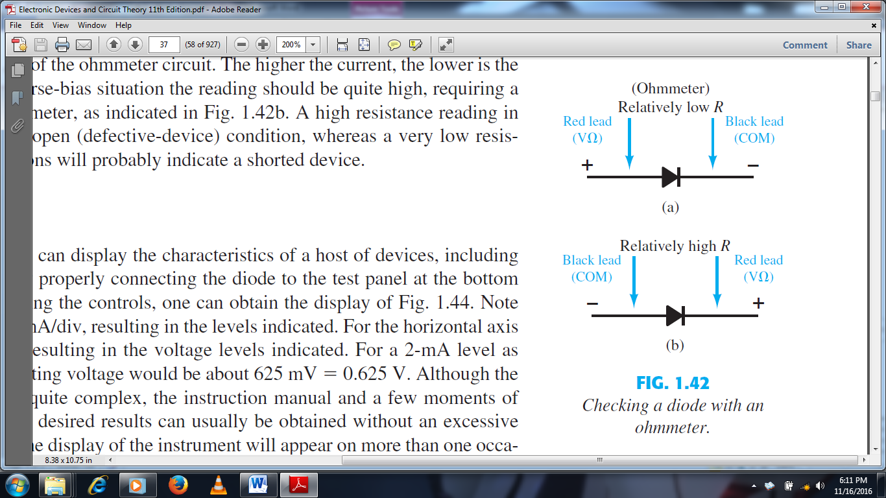

Figure: Measuring the resistance of a diode in (a) forward biasing and (b) reverse biasing.

1. **Forward-bias Diode Characteristics**
2. First we brought the breadboard, a DC supply, an Ammeter, a resistor and a diode and placed them on appropriate surface for doing experiments.
3. Then by using the breadboard we connected the power supply to the ammeter, then the ammeter to the resistor, then the resistor to the diode and lastly the diode back to the DC power supply. Here we took caution on connecting the correct ports (positive and negative) between our circuit elements. Here the diode is forward biased. Meaning the anode of the diode is connected to the positive terminal and the cathode to the negative terminal.
4. Also in step 2, we took caution while making the circuit on the breadboard. The breadboard has many holes in which some are connected vertically and some are connected horizontally. We used the vertically connected hole to create our circuit. If the same component is placed in holes that are connected together, then the line we formed will become short and the component we just place will not be used which misguided our circuit.
5. After this by setting the voltage source to the commanded amount. We checked whether we used the right amount of voltage or not by using a Multimeter. The Multimeter is connected the one end of the diode and another end of the resistor. Then we measured the voltage across the resistor and diode. Then we measured the current through the diode.
6. **Reverse-bias Diode Characteristics**
7. Here we applied the same procedures as what we did with forward-bias. The only difference is only that the direction of the diode is changed. To make it reverse biased we just filliped the diode around and connected the anode to the negative and the cathode to the positive terminal.
8. The rest steps are the same to that of Forward-bias.
9. We took measurements at assigned voltage points. Like before we measured the voltage across the resistor, voltage across the diode and current through the diode.

**Result and Discussion**

From the experiments we have done we have obtained the following measurements.

|  |  |
| --- | --- |
| Diode Testing | |
| Forward bias | Reverse bias |
| 0.638 |  |

|  |  |  |  |  |  |  |  |  |  |  |  |  |  |  |  |
| --- | --- | --- | --- | --- | --- | --- | --- | --- | --- | --- | --- | --- | --- | --- | --- |
| Forward-bias Diode Characteristics | | | | | | | | | | | | | | | |
| Vs (V) | 0 | 0.1 | 0.2 | 0.3 | 0.4 | 0.5 | 0.6 | 0.7 | 0.8 | 1 | 2 | 4 | 6 | 8 | 10 |
| VD(V) | 0 | 0.09 | 0.198 | 0.303 | 0.4 | 0.479 | 0.526 | 0.557 | 0.575 | 0.606 | 0.665 | 0.708 | 0.730 | 0.743 | 0.755 |
| VR (V) | 0 | 0 | 0 | 0.001 | 0.005 | 0.03 | 0.08 | 0.153 | 0.213 | 0.405 | 1.366 | 3.379 | 5.401 | 7.293 | 9.210 |
| ID (mA) | 0 | 0 | 0 | 0 | 0 | 0.2 | 0.4 | 0.7 | 1.1 | 2.1 | 6.3 | 16.3 | 26 | 35.4 | 45.5 |

|  |  |  |  |  |  |  |  |  |  |  |  |  |  |  |  |
| --- | --- | --- | --- | --- | --- | --- | --- | --- | --- | --- | --- | --- | --- | --- | --- |
| Reverse-bias Diode Characteristics | | | | | | | | | | | | | | | |
| Vs (V) | 0 | 0.1 | 0.2 | 0.3 | 0.4 | 0.5 | 0.6 | 0.7 | 0.8 | 1 | 2 | 4 | 6 | 8 | 10 |
| VD (V) | 0 |  |  |  |  |  |  |  |  |  |  |  |  |  | 10 |
| VR (V) | 0 |  |  |  |  |  |  |  |  |  |  |  |  |  |  |
| ID (mA) | 0 | 0 | 0 | 0 | 0 | 0 | 0 | 0 | 0 | 0 | 0 | 0 | 0 | 0 | 0 |

**Observations and Conclusion**

* In testing a diode it allows a current in the forward bias but disallow a current in the reverse bias. Thus we should take care when we connect terminal to the anode and cathode.
* In connecting a resistor in series with a diode in forward bias, we observed the following phenomena:
  + When the source voltage is increased the voltage of the diode decreases in a steady manner.
  + When the source voltage is increased the voltage drop across the resistor first remains small and then dramatically increases.

**References**

* Electronic devices and circuit Theory 10th edition, R. L. Boylestad and L. Nashelsky

***“We have neither received nor provided any help on the writing of this lab report.”***

_____________

**Thank you!**